CRYSTAL BALL PROJECT
Obtain the following images: (for pictures of you, be sure to use a flash!)
- Full length shot of yourself in a pose
- Waist-up shot of you to one side with your hand out
- An internet photo from either a place you’d love to visit or live (high quality!)
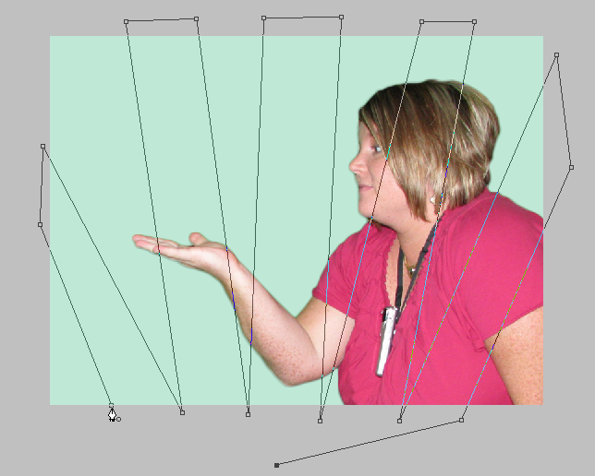
- Create a new image that is 800 pixels wide and 600 pixels high. Set resolution to 100ppi. Save as HANDSWORLD.PSD.
- Create a background layer that is a solid color.
- Create a “rays” shape layer that contains a pattern similar to that below. Use the pen tool and set fill color to white (be sure it is set to draw shape paths). Set layer blending mode to “Soft Light” and apply the Outer Glow Layer Style with 20% noise, 75% opacity, 20% spread, and 40px size.
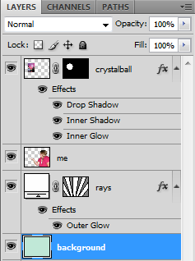
- Bring in the background and the full length shot of yourself. As they will be on separate layers, you will want to put them on one layer together—to do that, position as you want and then right click the top layer and select Merge Down. (HINT: Be sure to adjust levels or contrast before you do this; if you look out of place because your picture is bright and the one you are putting yourself if in is dark, that should be fixed!).
- On the merged layer, use the Elliptical Marquee Tool and make a round selection (hold Shift) to get over your image. Be sure it is full of “image” and not blank space (think crystal ball). You may Refine Edge, but do not use more than a 1px feather.
- Click the Mask Layer button to mask everything but the circular part.
- Click the layer thumbnail and position on your hand.
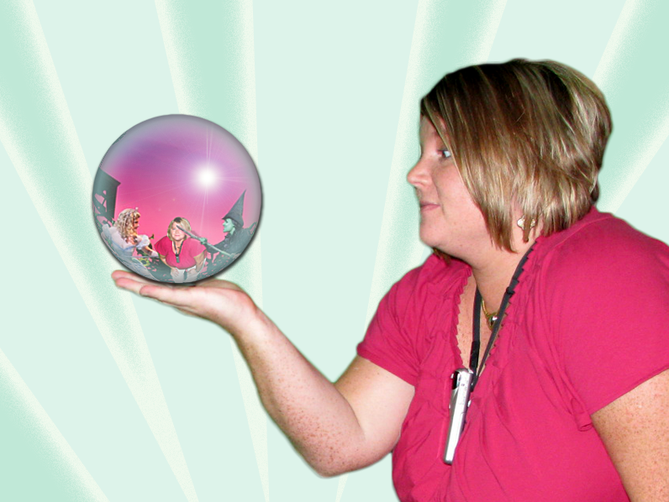
- Control+Click the layer thumbnail to select; then, click Filter>Distort>Spherize and set between 50-90% to make the selection look “rounded” (think crystal ball again!).
- Deselect; then use the Sharpen Filter (Filter> Sharpen>Smart Sharpen) to sharpen the image in the sphere.
- Add layer effects (Fx) for drop shadow, inner shadow, and inner glow. Adjust them so that it looks good. Change inner glow color to better match your background (instead of yellow).
- Add a lens flare filter (Filter> Render> Lens Flare) of your choice to the “crystal ball” layer for effect.
- Save and print landscape!

NAME:__________________________ HOUR: ______
CRYSTAL BALL PROJECT SCORING GUIDE
Requirement | Points Possible | Deducted
Background of image contains solid color, pen tool generated shape, and soft light blending mode with outer glow as indicated | 10
Quality of selection of self in appropriate pose (hand cupped) | 10
Crystal ball items includes image of place you’d like to be and includes self in appropriate pose, full length | 10
Crystal ball is spherized with drop shadow, inner glow, inner shadow and lens flare. | 10
Printed at 100% size in landscape orientation. | 5
TOTAL | 45

\
NAME:__________________________ HOUR: ______
CRYSTAL BALL PROJECT SCORING GUIDE
Requirement | Points Possible | Deducted
Background of image contains solid color, pen tool generated shape, and soft light blending mode with outer glow as indicated | 10
Quality of selection of self in appropriate pose (hand cupped) | 10
Crystal ball items includes image of place you’d like to be and includes self in appropriate pose, full length | 10
Crystal ball is spherized with drop shadow, inner glow, inner shadow and lens flare. | 10
Printed at 100% size in landscape orientation. | 5
TOTAL | 45

